Name: Bradley Willcott

ID: M198449

Date: 9 September 2021

Assessment Task – Portfolio (A 6)

Web Programming

Contents

Figures 2

Project Analysis 3

Purpose of website and required functionality 3

Functional Design and Architectural requirements 4

Architectural requirements 4

Prototype of Website UI Design 5

Target system of this application 8

The data storage design 9

Risk Assessment 10

Run Website 11

References 39

Tables

Table 1: Test results 11

# Figures

Figure 1 - Home page 5

Figure 2 - Add User page 5

Figure 3 - List Users page 6

Figure 4 - About page 6

Figure 5 - License page 7

Figure 6 – Home page 12

Figure 7 – Add User page - A 12

Figure 8 – Add User page - B 13

Figure 9 – Add user - A 13

Figure 10 – Add user - B 14

Figure 11 - Add user - C, confirmation 14

Figure 12 - Partial entry - A 15

Figure 13 - Partial entry - B 15

Figure 14 - Partial entry - C 16

Figure 15 - Partial entry - D 16

Figure 16 - Invalid email - A 17

Figure 17 - Invalid email - B 17

Figure 18 - Invalid email - C 18

Figure 19 - Invalid text in First name 18

Figure 20 - Invalid text in Last name 19

Figure 21 - Go to List Users page 20

Figure 22 - List Users 21

Figure 23 - Home page 22

Figure 24 - Display Add User page - A 23

Figure 25 - Display Add User page - B 24

Figure 26 - Add user - A 25

Figure 27 - Add user - B 26

Figure 28 - Add user - C, confirmation 27

Figure 29 - Partial data - A 28

Figure 30 - Partial data - B 29

Figure 31 - Partial data - C 30

Figure 32 - Partial data - D 31

Figure 33 - Invalid email - A 32

Figure 34 - Invalid email - B 33

Figure 35 - Invalid email - C 34

Figure 36 - Invalid text in First name 35

Figure 37 - Invalid text in Last name 36

Figure 38 - List all users 37

# Project Analysis

## Purpose of website and required functionality

The purpose of this website is to provide a means to administer user details. Specifically, their full name and their email address.

To achieve this purpose, the site must provide the ability to add new users and to list all current users.

## Functional Design and Architectural requirements

* Add user page
  + Will accept:
    - Name
    - Email
  + Information to be stored in a database
  + Data validation:
    - Name: regex => “[a-zA-Z]+([ ‘-]?[a-zA-Z]+)*”
    - Email: syntax ~><name>@<domain>
      * <name>: ”[a-zA-Z]+(\.[a-zA-Z0-9]+)*”
      * <domain>: ”[a-z]+[0-9]* (\.[a-z]+)*”
* Show all users page:
  + Display all the users created

### Architectural requirements

The Membership website must include navigation of:

* Add a user
* Show all users

## Prototype of Website UI Design

Figure - Home page

Figure - Add User page

Figure - List Users page

Figure - About page

Figure - License page

## Target system of this application

This application is targeted at any operating system/hardware configuration that provides a web server that runs PHP/HTML 5.

Suggested system:

* Hardware:
  + Intel I5 CPU
  + 8 Gb RAM
  + 1Tb storage (HDD/SSD)
  + Fast network connection hardware (WiFi/Cable)
* Operating system:
  + Linux – Fedora v34+
* Software:
  + Apache v9+
  + PHP v8+

## The data storage design

* Database: Human Resources
  + Table: Users
    - Fields:
      * Id: integer, auto increment
      * LastName: string, 30 characters
      * FirstName: string, 30 characters
      * Email: string, 60 characters
    - Indexes:
      * ID_index: unique, primary key
      * Name_index: LastName (asc), FirstName (asc)

# Risk Assessment

Based on my current knowledge of potential risks, I do not believe that my site has any.

One possible risk, SQL Injection, I believe has been neutralized in two ways:

1. The range of allowable characters is limited:
   1. In the two name fields: regex "/^[a-zA-Z]+([ '-]?[a-zA-Z]+)*$/"
   2. In the email field by the HTML 5 email setting on the form input field
2. There is currently no option to limit the User List SELECT statement, by the user.  
   Should this change in the future, then further measures will be necessary.

# Run Website

Table 1: Test results

|  |  |  |  |  |
| --- | --- | --- | --- | --- |
| Case | Description | Expected | Actual | Evidence |
|  | Test using FireFox: |  |  |  |
| #1 | Home page | Display Home page | As expected | Figure 6 |
| #2 | Add User page | Display Add User page | As expected | Figure 7  Figure 8 |
| #3 | Add new user: Mary Mills,  mmills@gmail.com | New user added | As expected | Figure 9  Figure 10  Figure 11 |
| #4 | Add partial data:  Greg Jones, no email | Message displayed, no record added | As expected | Figure 12  Figure 13  Figure 14  Figure 15 |
| #5 | Invalid email | HTML 5 message,  No new record. | As expected | Figure 16  Figure 17  Figure 18 |
| #6 | Invalid text in First name | Display error message | As expected | Figure 19 |
| #7 | Invalid text in Last name | Display error message | As expected | Figure 20 |
| #8 | List users | Display the list of current users | As expected | Figure 21  Figure 22 |
|  | Test using MS Edge: |  |  |  |
| #9 | Home page | Display Home page | As expected | Figure 23 |
| #10 | Add User page | Display Add User page | As expected | Figure 24  Figure 25 |
| #11 | Add new user:  Sally Mills,  Sally.mills@gmail.com | New user added | As expected | Figure 26  Figure 27  Figure 28 |
| #12 | Add partial data:  Harry Redmond, no email | Message displayed,  no record added | As expected | Figure 29  Figure 30  Figure 31  Figure 32 |
| #13 | Invalid email | HTML 5 message,  No new record. | As expected | Figure 33  Figure 34  Figure 35 |
| #14 | Invalid text in First name | Display error message | As expected | Figure 36 |
| #15 | Invalid text in Last name | Display error message | As expected | Figure 37 |
| #16 | List all users | Display List Users page | As expected | Figure 38 |

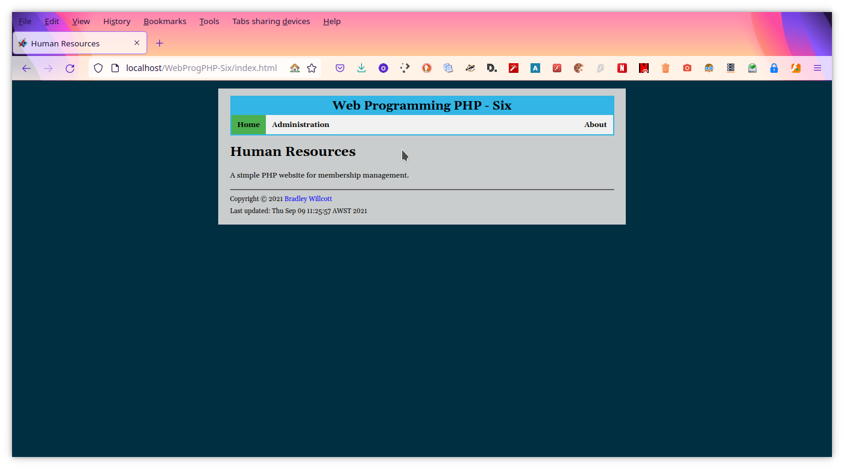

Figure 6 – Home page

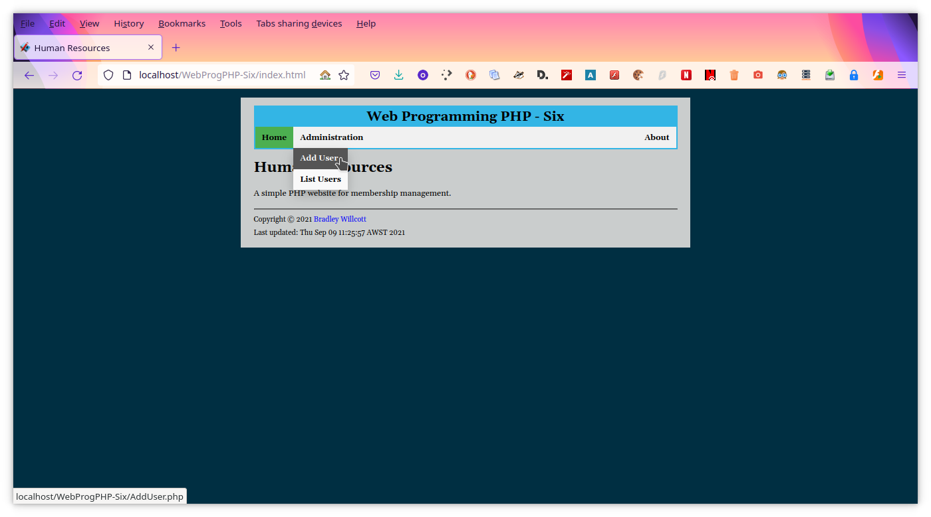

Figure 7 – Add User page - A

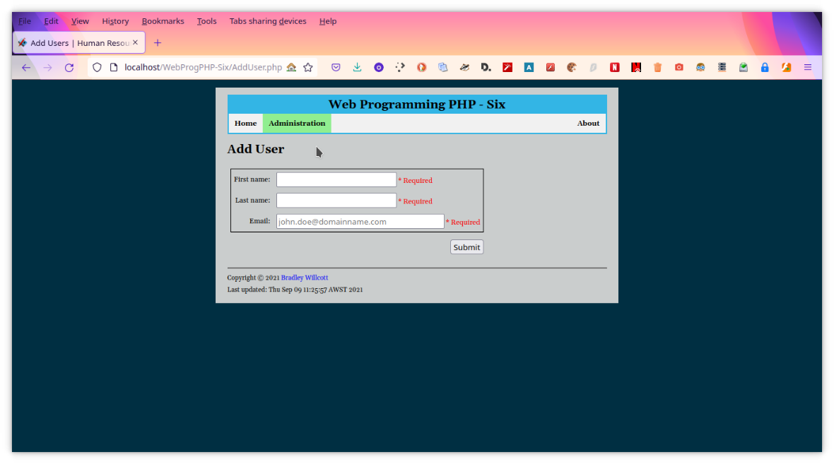

Figure 8 – Add User page - B

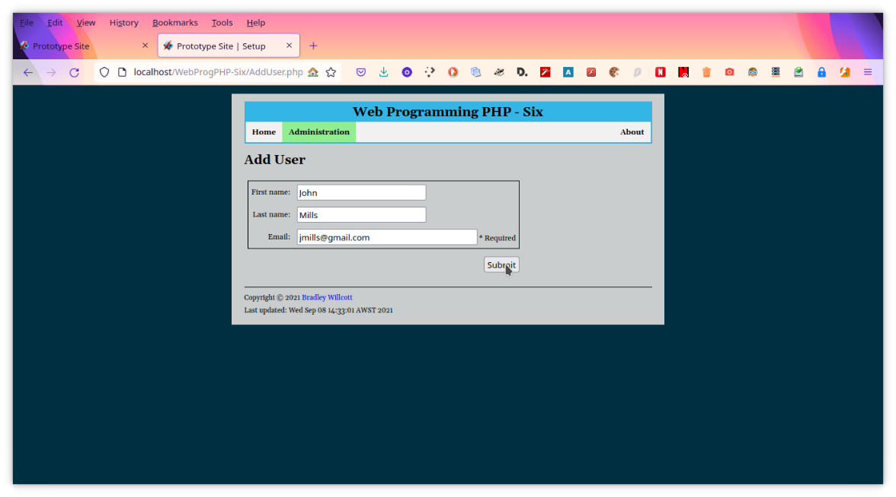

Figure – Add user - A

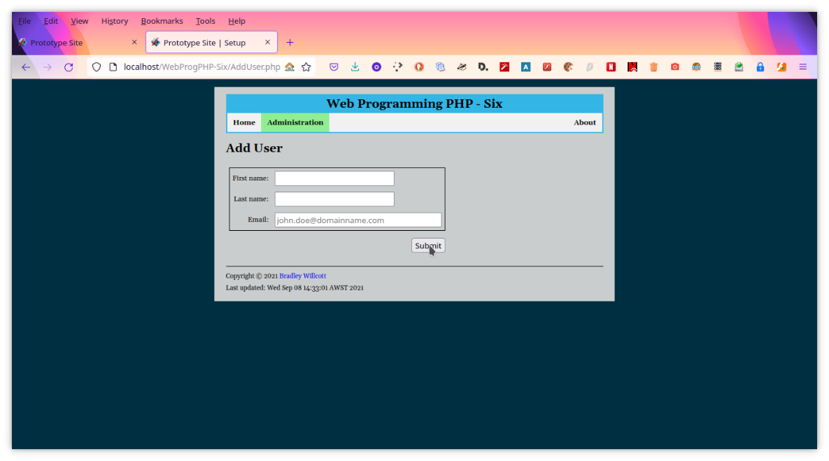

Figure – Add user - B

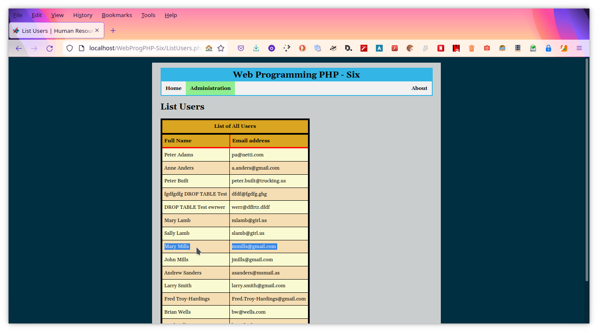

Figure - Add user - C, confirmation

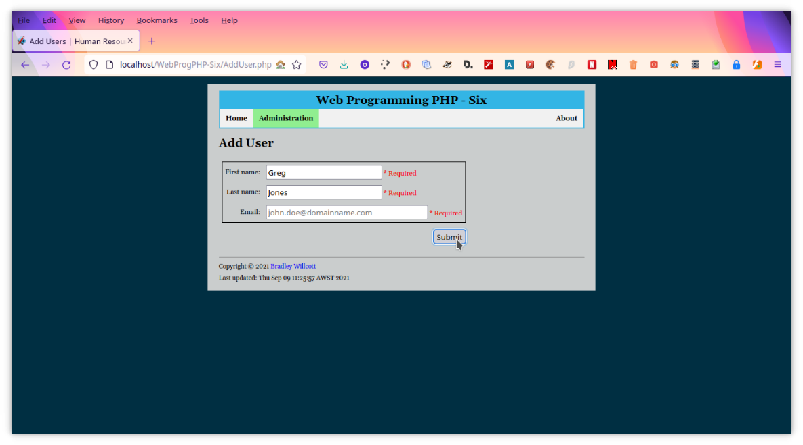

Figure - Partial entry - A

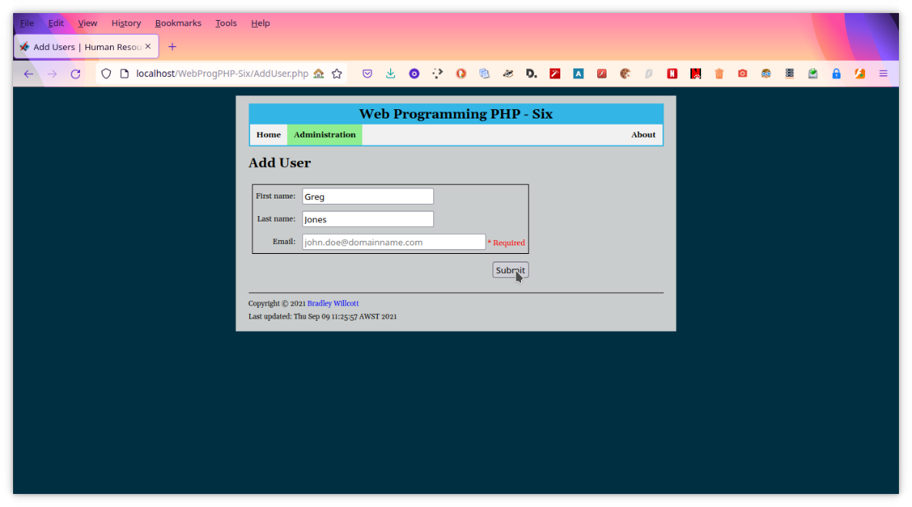

Figure 13 - Partial entry - B

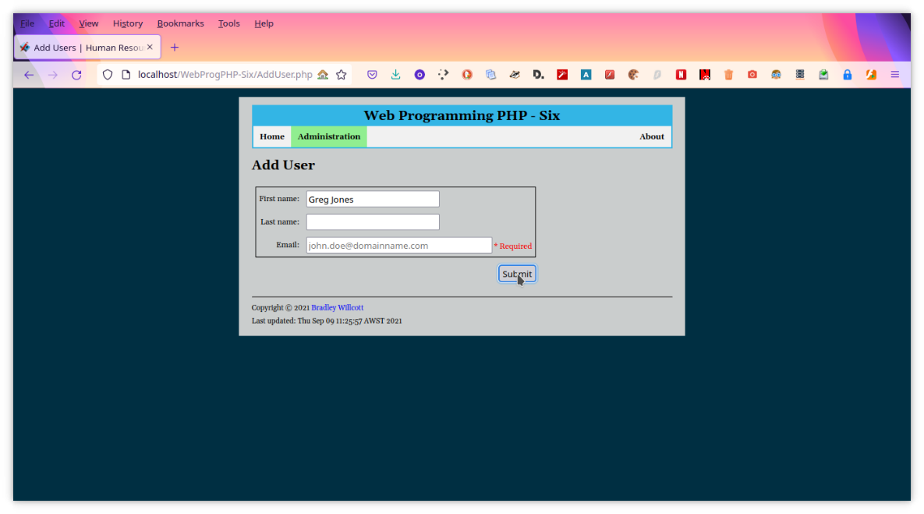

Figure 14 - Partial entry - C

Figure - Partial entry - D

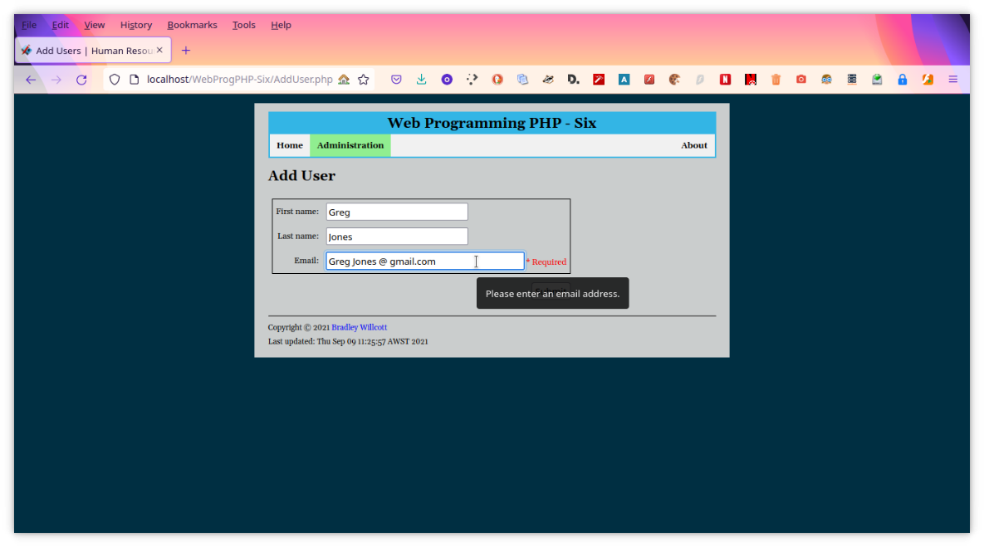

Figure 16 - Invalid email - A

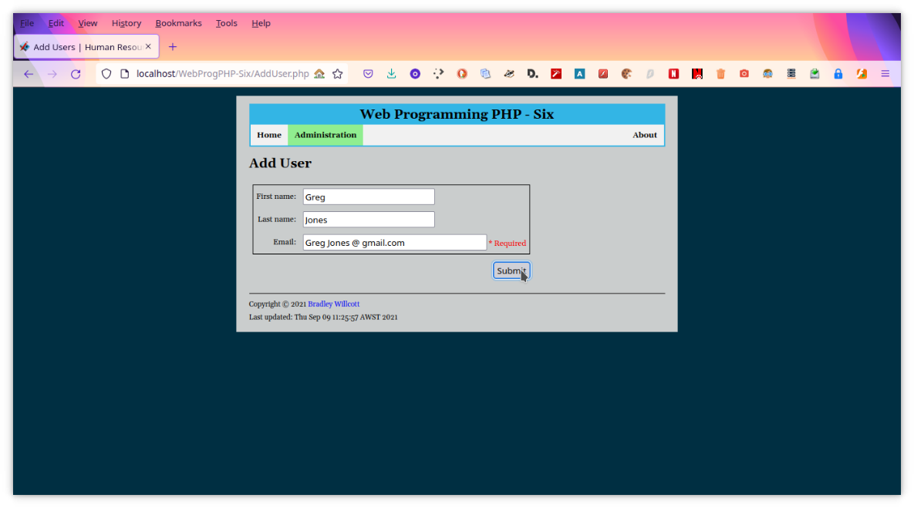

Figure 17 - Invalid email - B

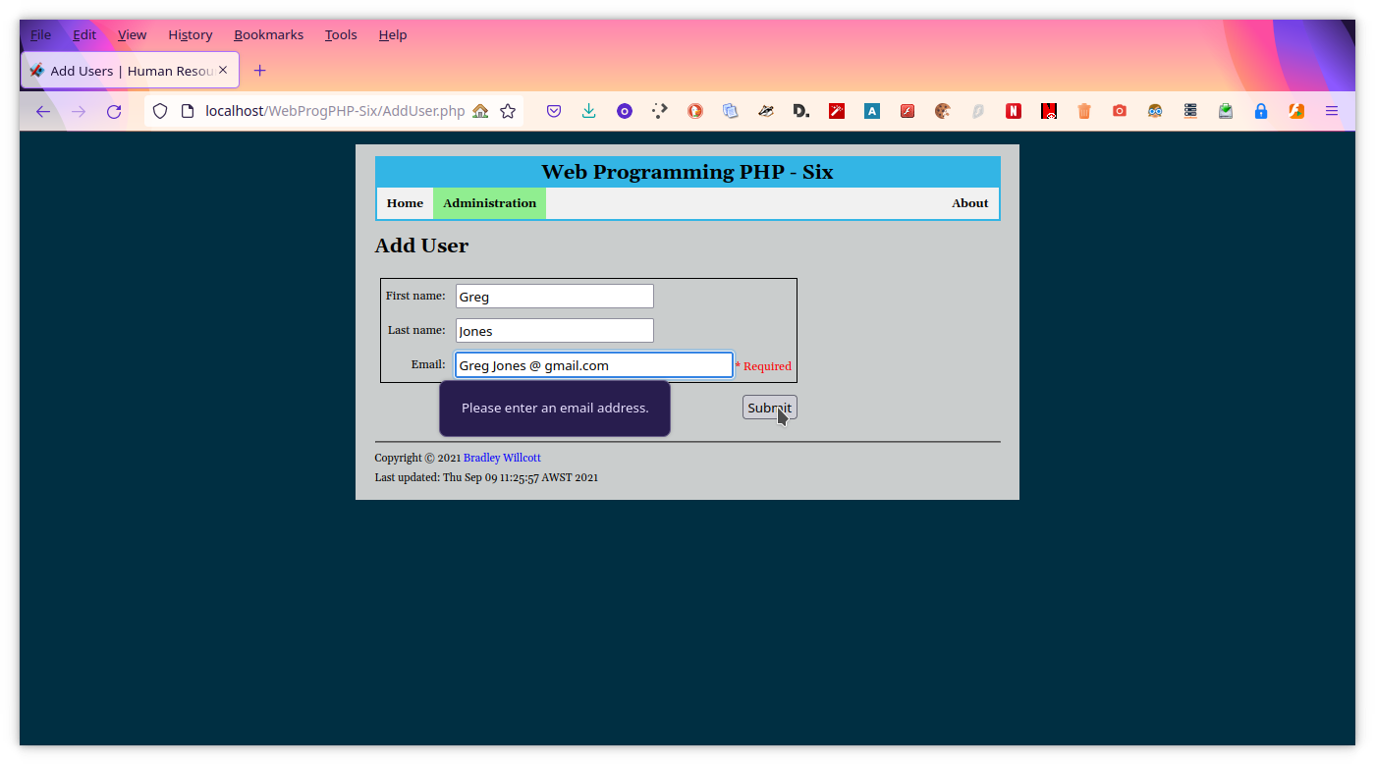

Figure 18 - Invalid email - C

Figure - Invalid text in First name

Figure - Invalid text in Last name

Figure - Go to List Users page

Figure - List Users

Figure - Home page

Figure - Display Add User page - A

Figure - Display Add User page - B

Figure - Add user - A

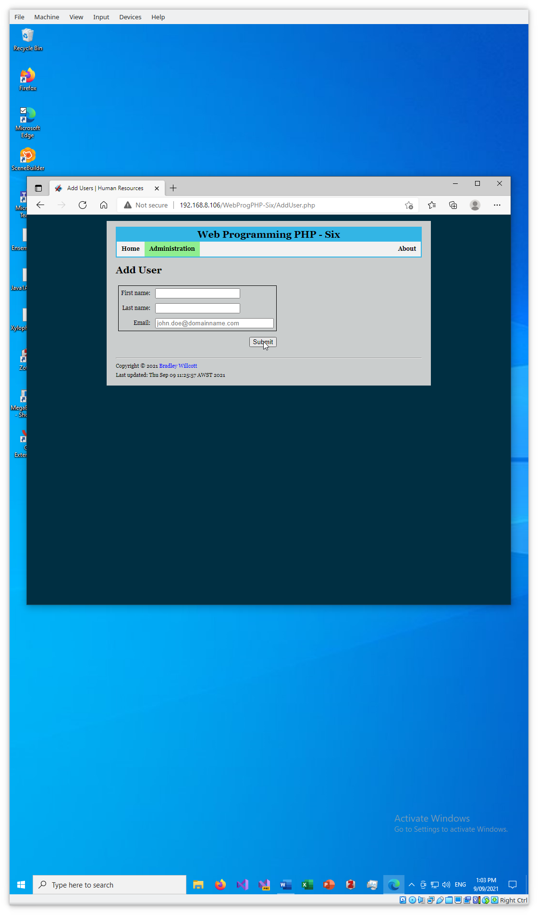

Figure - Add user - B

Figure - Add user - C, confirmation

Figure - Partial data - A

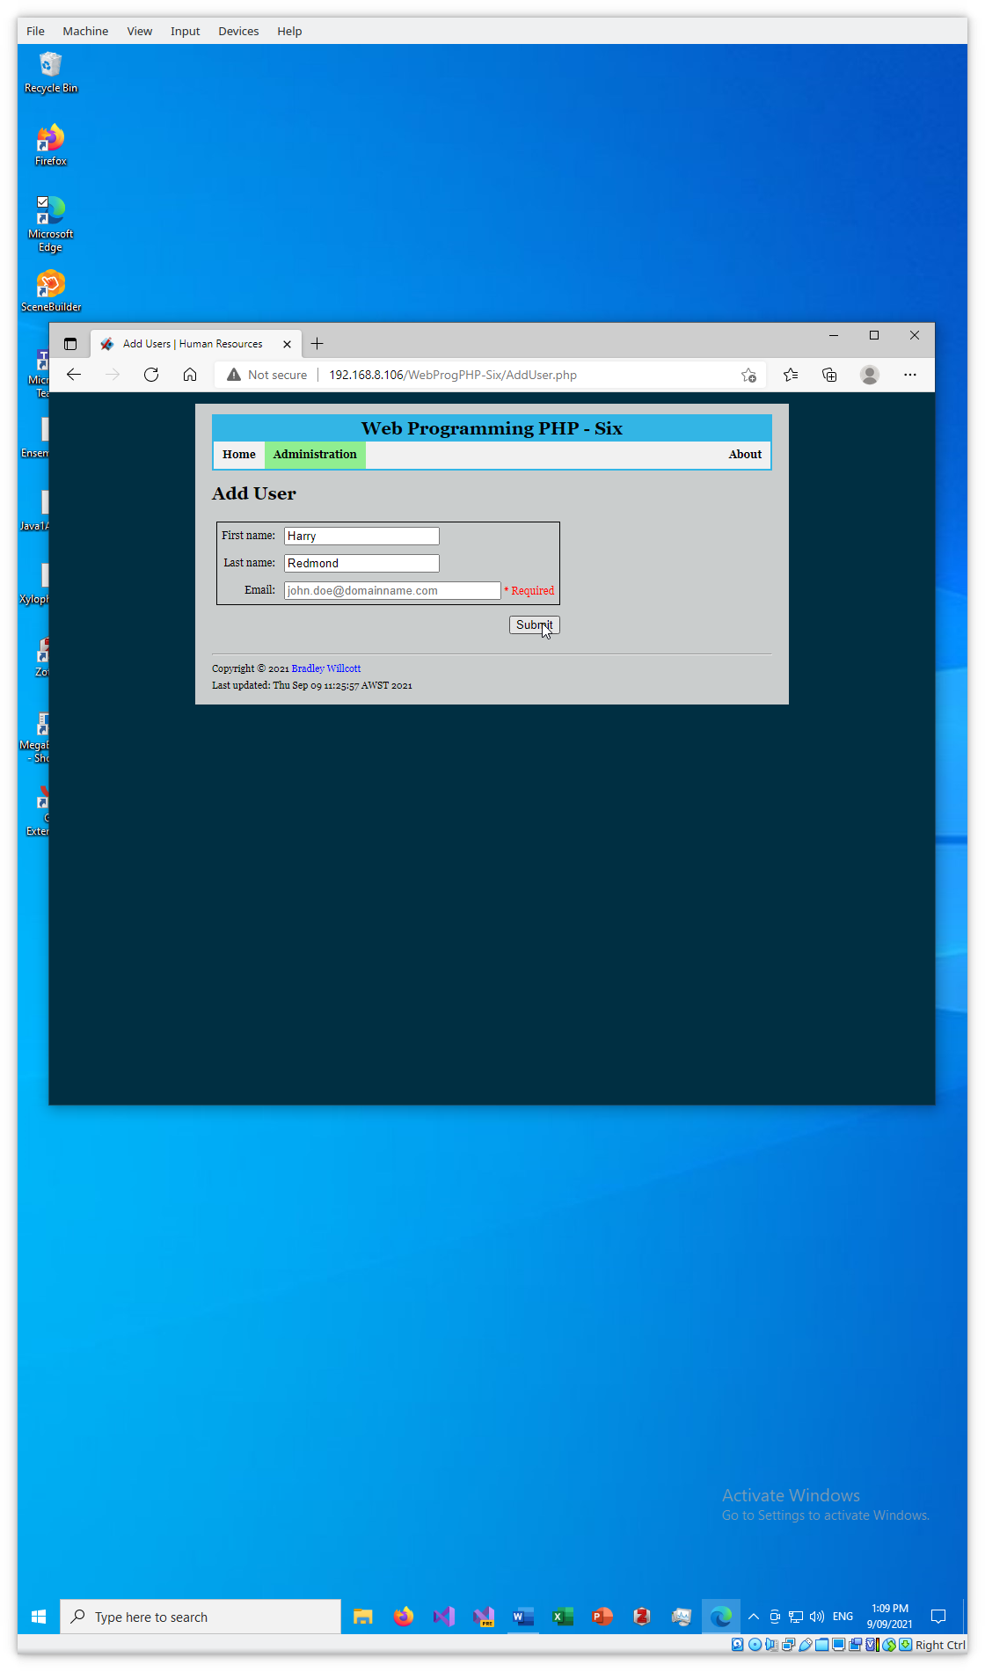

Figure - Partial data - B

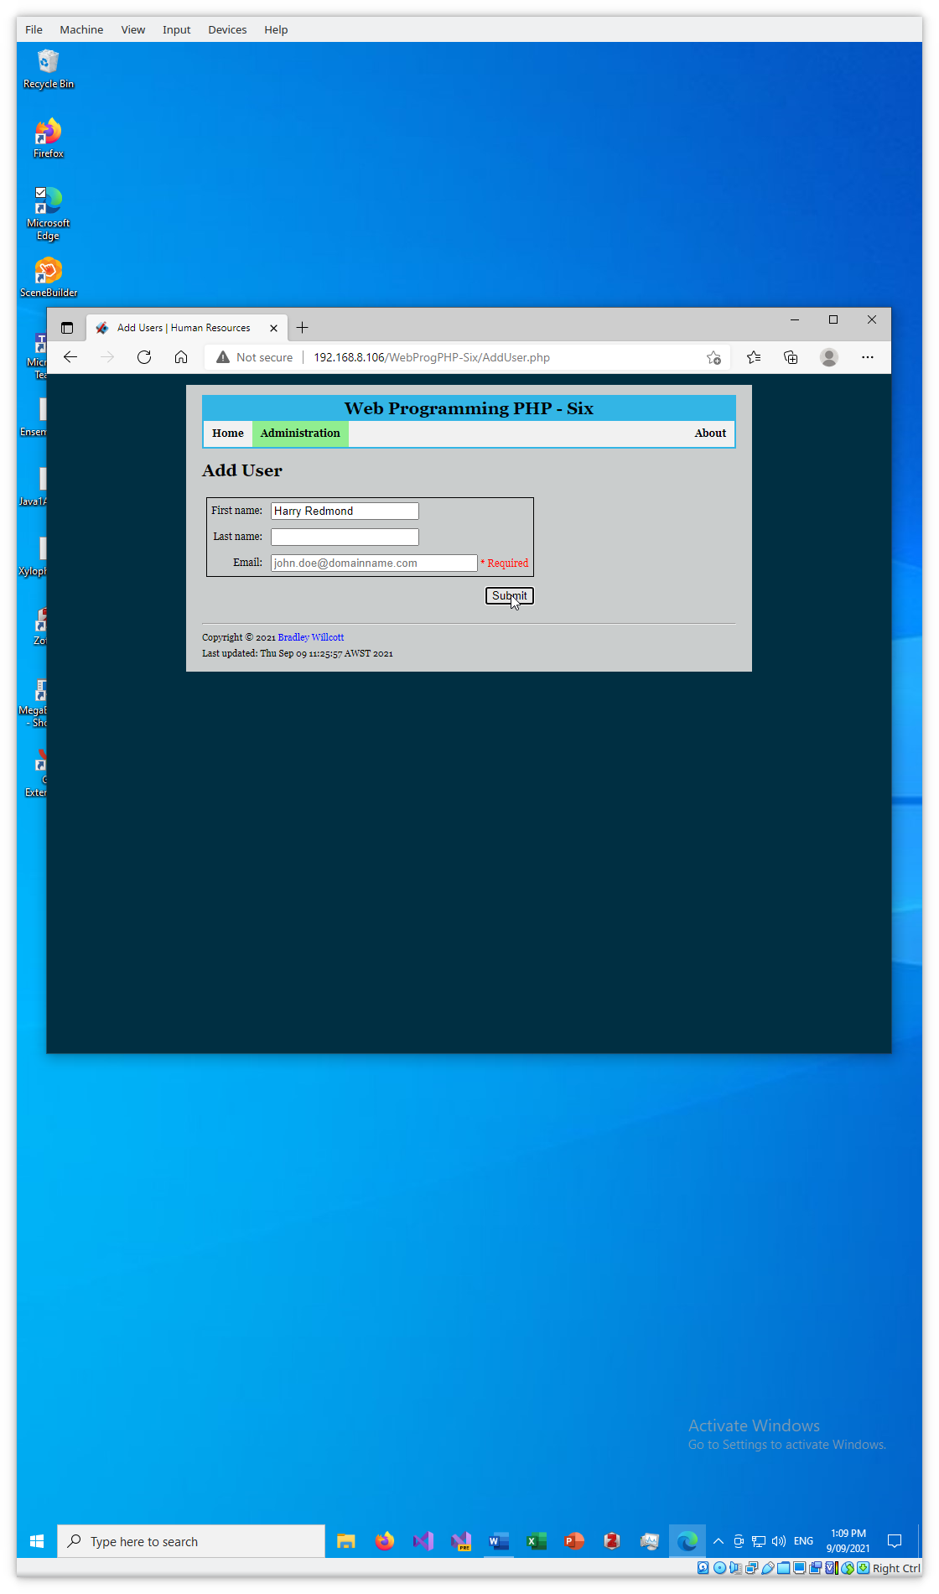

Figure - Partial data - C

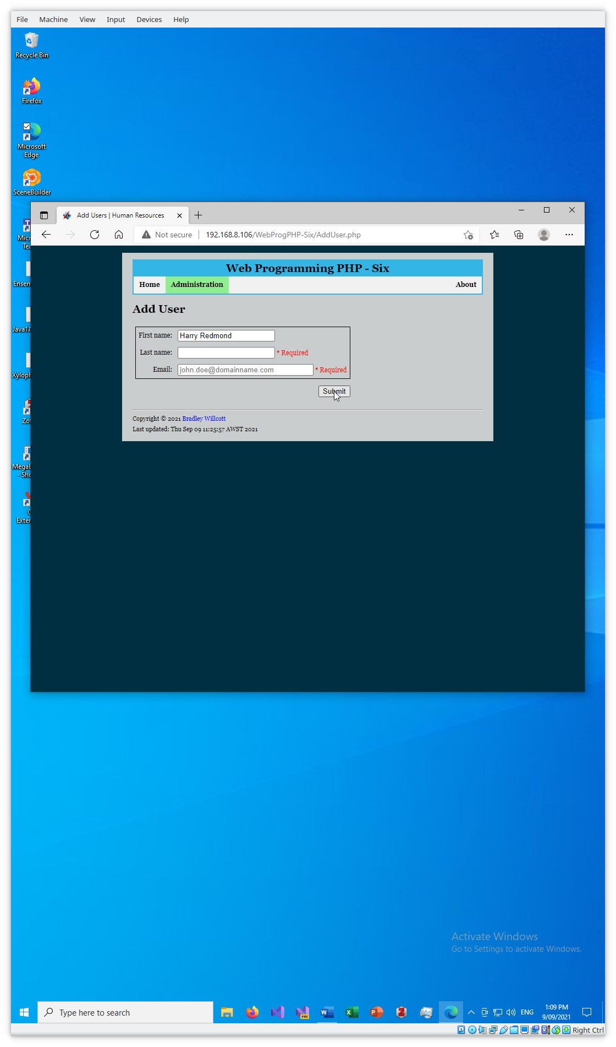

Figure - Partial data - D

Figure - Invalid email - A

Figure - Invalid email - B

Figure - Invalid email - C

Figure - Invalid text in First name

Figure - Invalid text in Last name

Figure - List all users

# References